istl

Online Registration Link:

Call for reservations

Accommodation and Venue:
Live Stream

12 CE NACCE includes OR
BCNA
(8 Phamracy)

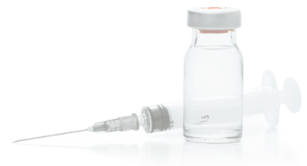

Seminar Schedule
Course Schedule

DAY 1 SATURDAY
9:00-10:00 Introduction, New Research, Assessment and Integrative Oncology
10:00 - 11:00 IV Therapy to Improve Quality of Life in the patient with Cancer
11:00-11:30 Exhibitor Break
11:30-12:00 Do Vitamins Fuel healing or cancer
12:30-14:00 Lunch break
14:00-15:00 Primary Therapies: HDIVC;
15:00-15:30 Exhibitor Break
15:30-16:30 Combine metabolic and HBOT
16:30-16:45 Artesunate
16:45-17:30 CBD and Oncology benefits

DAY 2 SUNDAY
9:00-10:00 Opioid use in cancer
10:00-10:30 Exhibitor break
10:30– 12:00 Curcumin, Copper TM
12:00-13:30 Lunch break
13:30-14:30 Novel IV agents
14:30-15:30 H202, Ozone therapies
15:30- 16:00 Exhibitor break
16:00-17:00 IV Protocols: Incorporating parenteral (IV) products discussed in lectures into intravenous protocols. –
Question & Answer time.

IV Therapies employed in the patient who has cancer are an invaluable addition to integrative oncology care. Research into new and novel areas of IV therapy in the cancer setting have added to the options for this type of care. This seminar is designed to bring these cutting edge ideas to light and reinforce tried and true methods as well.

Instructors for this seminar are:
Virginia Osborne, ND, Paul Anderson, ND, NMD
Brenden Cochran ND, NMD
Greg Jones NMD
Kelly Brink RN

Accreditation:

This 2-day Seminar is normally approved for up to 12 hours of CE credit.
Registration

This 2-day Advanced Seminar is designed for:
Naturopathic Doctors, Medical Doctors, Osteopathic Doctors, Registered Nurses, Medical Students and other interested medical professionals who have already been trained in the fundamentals of IV Nutrient Therapies.

Seminar registrants must have a current license
to practice medicine (ND, MD, DO, NP, PA, RN)
or proof of student enrollment at an accredited medical school.

Registration Fees:

Licensed Physicians and Health Care Professionals
$1400.00 early
$1600.00 late

Cancellations and Refunds

Refunds are subject to administration fee up to the early registration deadline. After the early registration deadline refunds will only be given in the event of emergency such as: death in family, personal injury, illness with physician’s letter (not written by you). No other refunds will be made.

A $100.00 penalty will be applied to returned checks or credit chargebacks - without exception.

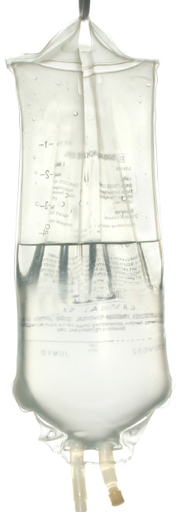
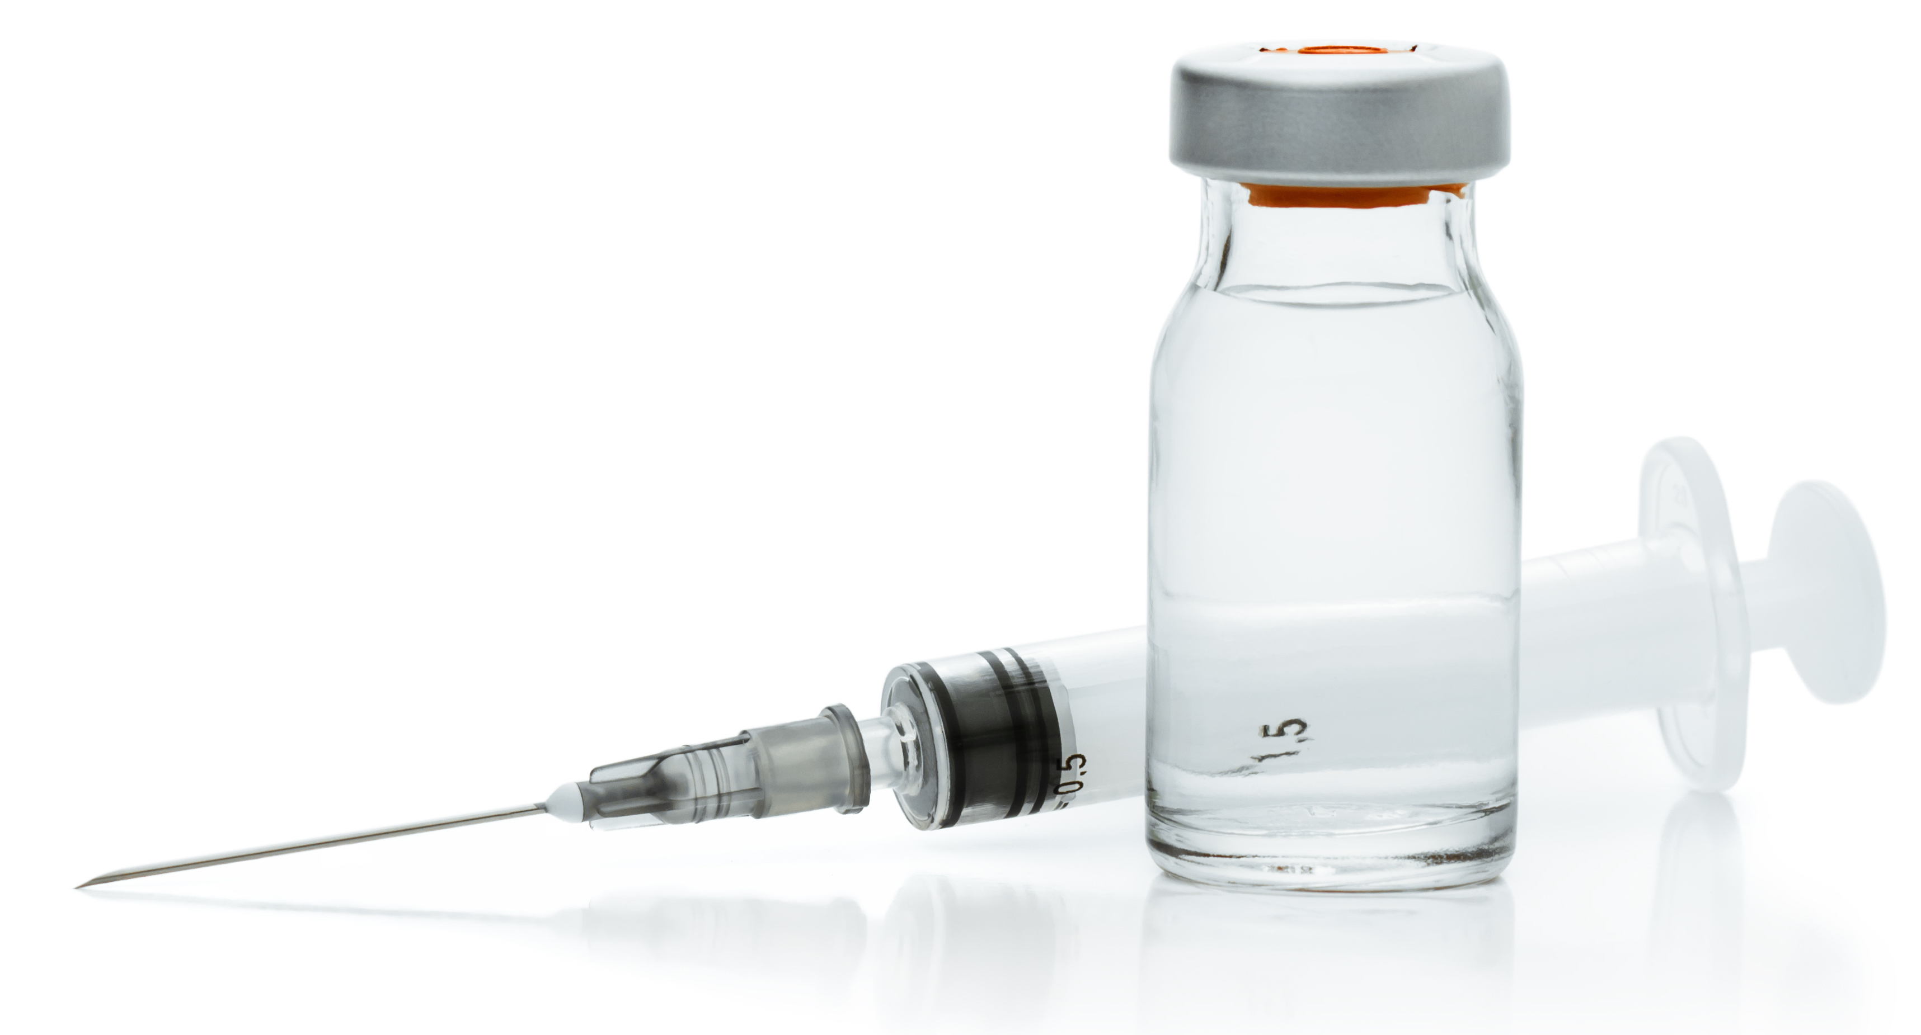
Clinical Applications and Advanced Topics of
IV Nutrient Therapies
in Oncology

January 17-18, 2026
Live Stream

IV Nutritional Therapy for Physicians (IVNTP) has presented seminars in the United States, Canada,
Mexico, The United Kingdom, and Taiwan.
Our instructors have between 10 and 25 years of teaching experience and a combined experience of more than 55 years of IV administration.

Questions or Comments?

IIVNTP
Tel: 541-777-3356
Email: ivnutritionaltherapy@gmail.com

www.ivnutritionaltherapy.com

IV Nutritional Therapy
for Physicians

Learn the Most Effective and Current
Application of Parenteral (IV) Micronutrients

IV Therapies employed in the patient who has cancer are an invaluable addition to integrative oncology. Research in novel areas of IV therapy have added to the options for adjunctive care. This seminar is designed to bring these cutting edge ideas to light and reinforce tried and true clinical applications.

Quality of Life Care:
Hydration, Radiation, and Chemotherapy Recovery

Novel IV Agents and Protocols to Improve
Cancer Care:
- ALA - Lipoic-Mineral Complexes
- Artesunate - Bicarbonate
- DCA - DMSO/MSM
- Calcitriol - Combination Therapies
- Germanium - Glycine
- Mistletoe - Opioids in Caner
- Many more
and more…

Plus the latest research in the use of IV Vitamin C,

Instructors for this seminar are:

Virginia Osborne, ND
Paul Anderson, ND
Brendan Cochran, ND
Kelly Bring RN
Dan Carter Adminsitration

