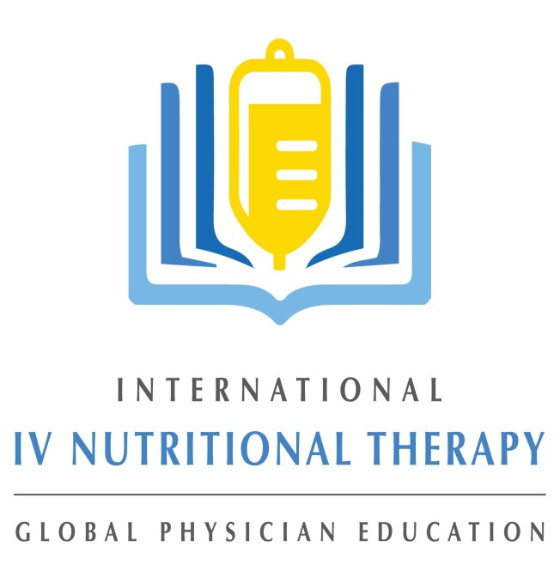

International IV Nutritional Therapy for Professionals (IIVNTP) has presented seminars in the United States, Canada, Mexico, The United Kingdom, and Taiwan. Our instructors have between 10 and 15 years of teaching experience and a combined experience of more than 40 years of IV administration.

**Questions or Comments?**

Telephone: (541) 777-3356

info@ivnutritionaltheapy.com

[www.ivnutritionaltherapy.com](http://www.ivnutritionaltherapy.com)

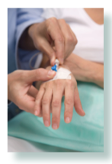

Our 2-day advanced seminar is designed for Naturopathic Doctors, Medical Doctors, Osteopathic Doctors, Registered Nurses, Medical Students and other interested medical professionals who have already been trained in the fundamentals of IV Nutrient Therapies.

Learn the most effective and current application of Parenteral (IV) Micronutrients: Vitamins, Minerals, Amino Acids, Botanical Extracts, Hydrogen Peroxide, DMSO, MSM, Lipoic Acid and Phosphatidylcholine. We will also cover the use of high dose IV vitamin C, central line access and care, germanium, sodium bicarbonate and IV protocols. Emergency medicine for clinics offering IV therapies. Our 2-day seminar is designed for Naturopathic Doctors, Medical Doctors, Osteopathic Doctors, Registered Nurses, Medical Students and other interested medical professionals.

**Pre-requisites**

Current license to practice medicine: ND, MD, DO, NP, PA, RN Student at accredited medical school: ND, MD, DO

**Accreditation**

This two day workshop is normally approved for 12 hours of CE credit.

Space is limited…so register today! Visit www.ivnutritionaltherapy.com for more Information including CEU approvals

**Seminar instructors**

Brenden Cochran ND Virginia Osborne ND

Shawna Kiker, ND,

Brenden McCarthy

Virginia Osborne ND

Ken Starr MD

Andre Belanger, Business

**Advanced Topics of IV NAD, Nutrient Therapies and Emergency Medicine**

**TAKE CHARGE : Business Foundations and Operation Marketing**

**May 13-14, 2022**

**Live Streaming Webinar**

**Practical Live in Person**

**Park City, UT**

**Day 3**:

**Business Schedule**:

09:00-09:15 introductions

09:15-10:15 Deliverables & treatment formulas (worksheet, template provided)

10:15-10:45 Exhibitor Break

10:45-11:30 Treatment strategies-Active and Proactive

11:30-12:00 7 primary systems

12:00-01:00 Lunch Break

01:00-02:30 7 primary systems, secondary systems (worksheet, template provided)

02:30-03:00 Exhibitor Break

03:30-04:30  6 stages flow

04:30-05:00  Q and A

**Registration**

This 2-day Advanced Seminar is designed for:

Naturopathic Doctors, Medical Doctors, Osteopathic Doctors, Registered Nurses, Medical Students and other interested medical professionals who have already been trained in the fundamentals of IV Nutrient Therapies.

Seminar registrants must have a current license   
to practice medicine (ND, MD, DO, NP, PA, RN)   
or proof of student enrollment at an accredited medical school.

**Registration Fees**

**Licensed Physicians and Health Care Professionals For any combination of 3 days**  
$1595.00Paid on or before April16,2021

$1895.00 Paid after April 16, 2021

**Students, Residents, First Year Graduates**

$ 995.00Paid on or before April16,2021

$ 1195.00 Paid after April 16, 2021

**NAD segment only**

$ 1100.00 on or before April 16, 2021

$­­­­­­1295.00 after April 16, 2021

**Business segment only**

$795.00on or before April 16, 2021

$995.00 after April 16, 2021

**Cancellations and Refunds**

Refunds are subject to a 25% for administration fee up to the early registration deadline. After the early registration deadline refunds will only be given in the event of emergency such as: death in family, personal injury, illness with physician’s letter (not written by you). No other refunds will be made.

A $100.00 penalty will be applied to returned checks or credit chargebacks - without exception.

**Online Registration**

**Seminar Venue: Live streaming Webinar**

**Practical: In Person**

**Live Stream Webinar**

**Seminar Schedule**

**Day 1**

0 9:00-10:00 Introduction NAD

10:00-11:00 IV Nutrients and NAD

11:00-11:15 Exhibitor Break

11:15-12:30 Hormones and NAD

12:30-01:30 Lunch Break

01:30-2:00 IV Nutrients and NAD Q and A

02:00-03:00 NAD and Chronic dz. patient

03:00-03:15 Exhibitor Break

03:15-04:15 NAD: Mental and Physical Performance

04:15-05:00 Infections/NAD Infusions Q and A

**Day 2**

09:00-10:45 NAD and Addictions

10:45–11:00 Exhibitor Break

11:00–11:15 Q and A

11:15-12:00 NAD Summary of Applications

12:00-01:00 Lunch Break

01:00-02:00 Emergency Medicine for the Office

02:00-03:15 Emergency Medicine for the office

03:15-03:30 Exhibitor Break

03:30- 5:00 Emergency Medicine for the office Question & Answer